NAME：KXH-9025-DP Intelligent electric hook type coil winding machine
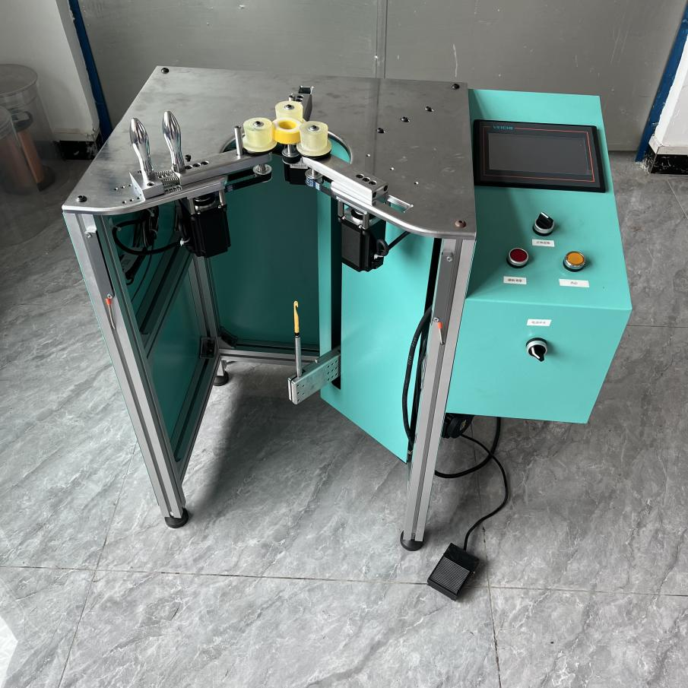

Wire Size : | 0.3-3.5MM
Min Finished I.D.: | It depends on the size of the needle
Starting Mode | power-driven
Winding mode | Hook winding driven by servo motor
Control mode | PLC+HMI control mode
Voltage | AC220V-50HZ
Machine weight | 60KG
Machine size | 780*450*800mm
Gross weight | 85KG
Wooden box size | 900*650*950mm

Specification：

Equipment description:
1. The 750w servo motor with planetary reducer hook line speed is fast while compatible with hook 3.0 line two can hook line

2. Controlled by PLC, the system is equipped with a 7-inch touch screen, which makes adjustment faster and parameters easy to save.

3. Three sets of 57 stepper motors drive the wiring wheel for wiring, so that the Angle of wiring is accurate; Speed, rotation Angle can be adjusted, positive and negative switch freely, easy to operate;

4. Equipped with leakage hook detection function to improve the efficiency of personnel operation number of accurate system with detection number of turns

5. The system can set multi-section winding method. The number of turns and Angle of each section can be set separately to effectively improve the winding efficiency of personnel

APPLICATION:

The KXH-9025-DP Intelligent Electric Hook Type Coil Winding Machine is highly suited for manufacturing a wide range of coil-based components, including toroidal inductors, toroidal transformers, toroidal current transformers, toroidal coils, toroid choke coils, power inductors, UPS inductors, converter inductors, and heavy-duty
Its intelligent electric hook-type design and precision hook mechanism make it particularly effective for handling both standard and heavy toroidal cores, ensuring consistent winding quality across diverse applications in power electronics, industrial machinery, and energy systems.

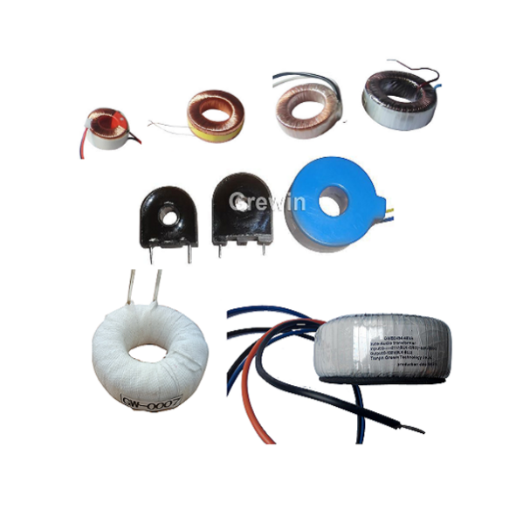

PRACTICAL APPLICATION :

Training for Customers on KXH-9025-DP Intelligent Electric Hook Type Coil Winding Machine Operation

1.All service engineers with 10 years of experience have received special technical training, including specialized expertise in the KXH-9025-DP Intelligent Electric Hook Type Coil Winding Machine, enabling them to effectively handle various breakdown issues specific to this intelligent hook-type winding equipment.

2.We guide users to accurately operate and maintain the KXH-9025-DP Intelligent Electric Hook Type Coil Winding Machine—with focused attention to its intelligent control systems, electric hook mechanisms, and precision winding adjustments—while providing free consultation about the production process technology of electronic products, particularly those involving coil winding applications.

3.To ensure the KXH-9025-DP Intelligent Electric Hook Type Coil Winding Machine operates normally, we conduct dedicated training on its intelligent functions, hook-type winding procedures, usage, and maintenance through English manuals, model-specific instructional videos, and online guidance, tailored to the unique requirements of this intelligent electric hook-type coil winding equipment.
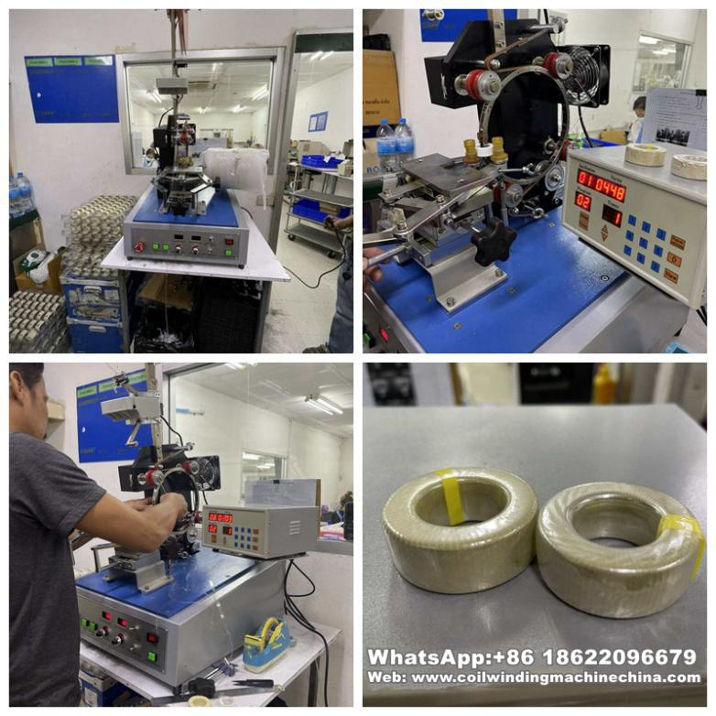

PACKAGING:

Packaging Material: Carton/Wooden case with foam inside.
1.General package(Paper carton or plastic bag): For small euipped parts for Hook Type Transformer Winding Machine, Package it with form and pack paper to guarantee unbroken during the transport.
2.Wooden case package: For larger scale Hook Type Transformer Winding Machine,we have special skilled carpenter, who would make the proper wooden case with exact thickness,density,length. The up arrow ↑marked on the outer wooden case. Buffer material would be put in the wooden case to prevent crack and shock.

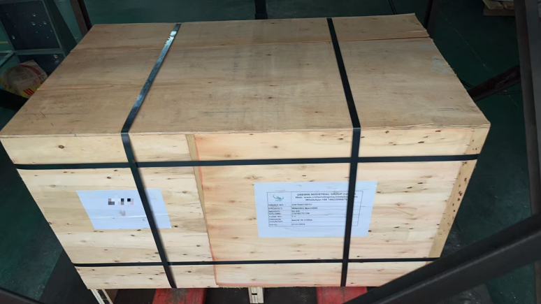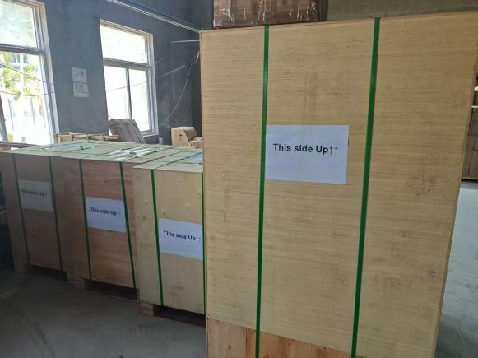

FACTORY:
We, KIOXIA LIGHT RING EQUIPMENT GROUP CO.,LTD., have been experts in winding machine lines for 28 years, with our advanced product portfolio featuring smart winding solutions like the KXH-9025-DP Intelligent Electric Hook Type Coil Winding Machine—an intelligent system equipped with electric hook technology for precise coil winding, embodying our technical prowess in smart manufacturing equipment.

Our KIOXIA LIGHT RING brand holds authoritative certifications and recognitions, including ISO9001:2015, CE approvals, multiple machine patents (encompassing key innovations in models like the KXH-9025-DP Intelligent Electric Hook Type Coil Winding Machine), and the official designation of "high-tech enterprise" by the government. These credentials fully validate the reliability, intelligence, and technical excellence of our entire product range, reinforcing our commitment to delivering advanced winding solutions for diverse coil manufacturing needs.
